**Report On**

**Automatic Street Light Control System with LDR and Relay**

Course Name: Career planning and development-||

Course code: ART-203

**Prepared for**

**Mohammad Musa**

Coordinator and Senior Lecturer of CTHM

IUBAT

**Prepared by**

**Md. Ayub Hossain**

ID # 13105189

Program: BSEEE

Sec- H

**IUBAT-International University of Business Agriculture & Technology**

Date of Submission: 19 March 2016

**Letter of Transmittal**

The Course Instructor, Mohammad Musa

IUBAT-International University of Business Agriculture and Technology, Uttara Model Town, Dhaka.

Dear Sir,

With due to respect that I am a student of ART 203. It is great pleasure for me to have a change to prepare a report on **“**Automatic Street Light Control System with LDR and Relay”. You would be glad to know that my investigation is to control the street light automatically with LDR and Relay. My expectation is that my will help me in my practical field and extend my knowledge border. For my kind consideration would like to mention that there might be some mistakes due to limitation of my knowledge, financial condition and my time limitation.

Thanks you for giving me the opportunity to do the research paper and to learn a lot of things during the preparation of reports.

Sincerely

………………......

Md. Ayub Hossain

**Table of contents**

Titles fly........................................................................................................................................... i

Title page........................................................................................................................................ ii

Letter of transmittal....................................................................................................................... iii

Acknowledgement......................................................................................................................... iv

Executive Summary........................................................................................................................ v

Table of contents..........................................................................................................................1-2

1. Background ................................................................................................................................3

2. Introduction..................................................................................................................................4

3. History..........................................................................................................................................4

4. Objective of the project................................................................................................................5

5. Block Diagram.............................................................................................................................5

5.1 Block Diagram Explanation.......................................................................................................6

# 6. Microcontroller…………………………………………………………………………………6

6.1 Pin Diagram......................................................................................................................7

6.2 Pin Description...................................................................................................................8

6.3 Microcontroller Architecture.............................................................................................9

6.3.1. Microprocessor has following instructions to perform.................................................9

6.3.2. 89c51 micro controller architecture……………………….…………………………..9

6.4 Functional Block Diagram of Microcontroller................................................................10

7. Hardware Description................................................................................................................11

7.1. LDR (Light Dependent Resistors)……………………………………………………..11

7.2. Light sensor circuit…………………………………………….………………………12

8. Relay…………………………………………………………………………………………..13

8.1. Operation………………………………………………………………………………13

# 8.2. Automatic Switching Of Street Lights by Using LDR and Relay……………..…14-15

9. Power Supply ........................................................................................................................16

9.1. Circuit Features.................................................................................................................16

9.2. Block Diagram..................................................................................................................17

9.3. Circuit Diagram...............................................................................................................17

9.4. Basic Power Supply Circuit.............................................................................................18

9.5. Transformer Rating..........................................................................................................19

9.6. Construction ...................................................................................................................19

10. Future Enhancement.............................................................................................................19

11. Conclusion……………………………………………………………………...……………20

12. References.............................................................................................................................20

# LIST OF FIGURES

Figure1: Block diagram of automatic street light control system with

LDR and microcontroller……………………………………………………..…………………5

Figure 2: Pin Diagram of microcontroller...................................................................................7

Figure 3:Pin description of microcontroller..................................................................................8

Figure 4: Functional Block Diagram of Microcontroller.............................................................10

Figure 5: LDR (Light Dependent Resistors)...............................................................................11

Figure 6: Light sensor circuit……………………………………………………………………12

Figure 7: Relay ......................................................................................................................13

Figure 8: Relay in the circuit.......................................................................................................14

Figure 9: Automatic Switching Of Street Lights by Using Ldr and Relay..................................15

Figure 10: Circuit Features..........................................................................................................16

Figure 11: Block Diagram of Power supply................................................................................17

Figure 12: Circuit diagram of A.C to D.C converter.................................................................17

**EXECUTIVE SUMMARY**

The existing lighting control system was developed uniquely for the target centre at the time of construction and is a one of a kind system. Our country is suffering from power crisis for a long time. Although some times because of our ignorance, we see street lights are on in the day. So we always suffer from this electricity crisis. By using automation to our street lights controlling system we can not only save our energy but also save human labour. Here we will show how we can make a controlling system easily by using LDR and Relay, microcontroller and small amount of power supply. The present system is like, the street lights will be switched on in the evening before the sun sets and they are switched off the next day morning after there is sufficient light on the roads. As a result the electricity waste occurs greatly all over the country. But the actual timings for these street lights to be switched on are when there is absolute darkness. This project gives the best solution for electrical power wastage. Also the manual operation of the lighting system is completely eliminated. In our project we are using LDR, which varies according to the amount of light falling on its surface, this give an indication for us whether it is a day/night time. Bridge type full wave rectifier is used to rectify the ac output of secondary of 230/12V step down transformer. The programming language used for developing the software to the microcontroller is Embedded/Assembly. The KEIL cross compiler is used to edit, compile and debug this program. Here in our application we are using AT89C51 microcontroller which is Flash Programmable IC. We believe that our idea provides better than the existing system. In the present project street lights are taken into consideration where the above discussed factors are rectified in them.

We have placed IR sensors in both sides of the road, which can be controlled by Micro controller (AT89C51).The IR‘s will be activated only on the night time. If any obstacle crosses the IR, automatically particular light will be ON, for few seconds.7805 three terminal voltage regulators is used for voltage regulation. Bridge type full wave rectifier is used to rectify the ac output of secondary of 230/12V step down transformer. The programming language used for developing the software to the microcontroller is Embedded/Assembly. The KEIL cross compiler is used to edit, compile and debug this program. Here in our application we are using AT89C51 microcontroller which is Flash Programmable IC. We believe that our idea provides better than the existing system. In the present project street lights are taken into consideration where the above discussed factors are rectified in them. There have been many advancements taking place in the semiconductor industry leading to more and more advancements in wireless technology. The main aim of the project is to save the power; by using effectively we can save more power, as we know that there is shortage of power nowadays in every where mostly in villages Nowadays, human has become too busy and he is unable to find time even to switch the lights wherever not necessary. This can be seen more effectively in the case of street lights. The present system is like, the street lights will be switched on in the evening before the sun sets and they are switched off the next day morning after there is sufficient light on the roads. But the actual timings for these street lights to be switched on are when there is absolute darkness. This type of regulation is ideal for having a simple variable bench power supply. Actually this is quite important because one of the first projects a hobbyist should undertake is the construction of a variable regulated power supply. While a dedicated supply is quite handy e.g. 5V or 12V, it's much handier to have a variable supply on hand, especially for testing. Most digital logic circuits and processors need a 5 volt power supply.

**Background:**

Our country is suffering from power crisis for a long time. Although some times because of our ignorance, we see street lights are on in the day. The project Automatic Street Light Control System with LDR and Relay has been successfully designed and tested. Here we are saving lot of power without any wastage, by these advanced technologies we can design many more systems which can be done by solar lights and through these solar lights we have a vast usage at the same time we can do automatic systems instead of doing it manually. The main aim of the project is Automatic street power saving system with LDR; this is to save the power. We want to save power automatically instead of doing manual. So it’s easy to make cost effectiveness. This saved power can be used in some other cases. So in villages, towns etc we can design intelligent systems for the usage of street lights. The report presents a new and innovative approach to managing street lighting systems. When combining both the sunrise/sunset feature with modern communications intelligent control of the street lighting system will offer significant cost savings because of reduced energy consumption and lower maintenance and operation cost.

**2.** **Introduction**

The idea of designing a new system for the streetlight that do not consume huge amount of electricity and illuminate large areas with the highest intensity of light is concerning each engineer working in this field. Providing street lighting is one of the most important and expensive responsibilities of a city. Lighting can account for 10-38% of the total energy bill in typical cities worldwide [1]. Street lighting is a particularly critical concern for public authorities in developing countries because of its strategic importance for economic and social stability. Inefficient lighting wastes significant financial resources every year, and poor lighting creates unsafe conditions. Energy efficient technologies and design mechanism can reduce cost of the street lighting drastically.

Manual control is prone to errors and leads to energy wastages and manually dimming during mid night is impracticable. Also, dynamically tracking the light level is manually impracticable. The current trend is the introduction of automation and remote management solutions to control street lighting [2].

There are various numbers of control strategy and methods in controlling the street light system such as design and implementation of CPLD based solar power saving system for street lights and automatic traffic controller [1], design and fabrication of automatic street light control system[3], automatic street light intensity control and road safety module using embedded system [4], automatic street light control system [5], Intelligent Street Lighting System Using Gsm [6], energy consumption saving solutions based on intelligent street lighting control system [7] and A Novel Design of an Automatic Lighting Control System for a Wireless Sensor Network with Increased Sensor Lifetime and Reduced Sensor Numbers [8].

In this paper two kinds of sensors will be used which are light sensor and photoelectric sensor. The light sensor will detect darkness to activate the ON/OFF switch, so the streetlights will be ready to turn on and the photoelectric sensor will detect movement to activate the streetlights. LDR, which varies according to the amount of light falling on its surface, this gives an inductions for whether it is a day-night time, the photoelectric sensors are placed on the side of the road, which can be controlled by microcontroller PIC16f877A. The photoelectric will be activated only on the night time. If any object crosses the photoelectric beam, a particular light will be automatically ON. By using this as a basic principle, the intelligent system can be designed for the perfect usage of streetlights in any place.

The block diagram of street light system as shown in Fig. 1 consists of microcontroller, LDR, and photoelectric sensor. By using the LDR we can operate the lights, i.e. when the light is available then it will be in the OFF state and when it is dark the light will be in ON state, it means LDR is inversely proportional to light. When the light falls on the LDR it sends the commands to the microcontroller that it should be in the OFF state then it switch OFF the light, the photoelectric sensor will be used to turn ON or OFF the light according to the presence or absent of the object. All these commands are sent to the controller then according to that the device operates. We use a relay to act as an ON/OFF switch.

Table 1 Photoelectric sensor specifications

|  |  |
| --- | --- |
| Photoelectric Sensors (MC005) | |
| Sensing range | 3-80 cm |
| Sensing object | Translucency, opaque |
| Supply voltage, current | DC 5 V, 100mA |
| Output operation | Normally open |
| Output | DC three-wire system (NPN) |
| Diameter, Length | 18mm, 45mm |
| Ambient temperature | -25_70 |

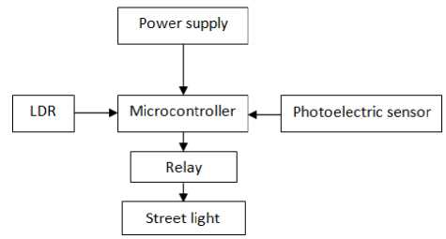

Fig. 1 Block diagram of street light system

**History of Street Lighting**

Historically, street lighting of roads and streets was introduced to combat crime after

daylight hours. Although this is still a major justification for installing and maintaining

Streetlights, the chief purpose now is to reduce automobile accidents during nighttime driving

[13]. There are records of attempts to light public places and crossroads occurring as long ago

as the fourth century AD when wood fires were used in Jerusalem. This may only have been at

Times of special festivities. In the tenth century, the Arabs are said to have lit miles of streets in

Cordoba [1]. Electric street lighting in Paris was in use as early as 1830 when arc lamps were

used for public lighting in the Place de la Concorde. A similar lamp was mounted in Hungerford

Bridge, London in 1849. However, it was not until 1870 that the efficiency of light systems

improved to the point where any appreciable length of street lighting was installed. In London, a

road from Westminster to Waterloo was lit by a string of forty lamps in 1879. Most all city

streets of record were lit by gas flame arcs by 1913. In 1879, Joseph Swan invented the electric

filament lamp. Electric lighting developed steadily; however, gas lighting was predominant due

to the gas infrastructure already in place along city streets. The use of electricity for street lighting became prevalent when the discharge lamp was introduced and made commercially available in 1910. Discharge lamps paved the way for the modern lamps of today. In 1932, high-pressure mercury (MBF) and low-pressure sodium lamps

(LPS) were used for street lighting in Britain. Streetlights of today are primarily of the high

pressure and low-pressure sodium, and metal halide types. These lights are mostly turned on and

off by a photocell. Prior to the photocell, streetlights were controlled by a sundial, or solar dial

time switch [14], which operates on the same principle as that proposed by SOLIMS. SOLIMS

is a system that gathers intelligent data from streetlights, and communicates that data back to the

central office. Data collected include, voltage, current and power consumption. This basic

intelligent data is used to determine the status of groups of streetlights and identify their

geographical location. SOLIMS would also send remote signals to turn streetlights on and off

using Astrologic time. SOLIMS offers complete automation of the existing lighting system with

minimal change in day-to-day utility company operations of line crew personnel.

Historic Street Light Sources

▪ Incandescent (8-20 LPW)

▪ Magnetic Ballast Linear Fluorescent (30-60 LPW) – 1950s and 60s

▪ Mercury Vapor (30-60 LPW) - Federal EPACT legislation banned as of January 1, 2008

Current Street Lights in Use

▪ High Pressure Sodium (80-120 LPW) – Amber-gold color and low color rendering

▪ Low Pressure Sodium (100-200 LPW) – Distinctive amber color

▪ Metal Halide (60-120 LPW) - Crisp white light and shorter life than HPS

## 4. Objective of the Project

The main consideration in the present field technologies are Automation, Power consumption and cost effectiveness. Automation is intended to reduce man power with the help of intelligent systems. Power saving is the main consideration forever as the source of the power(Thermal, Hydro etc.,)are getting diminished due to various reasons. The main aim of the project is Automatic street power saving system with LDR; this is to save the power. We want to save power automatically instead of doing manual. So it’s easy to make cost effectiveness. This saved power can be used in some other cases. So in villages, towns etc we can design intelligent systems for the usage of street lights.

**5. Block Diagram:**

POWER

SUPPLY

89C51 MICROCONTROLLER

LDR

RELAY

Figure1: Block diagram of automatic street light control system with LDR and microcontroller

**Block Diagram Explanation:**

In this project, we are going to switch off the street lights automatically as the day starts. The duration of the day differs from season to season, accordingly our module works based upon the light intensity so as to when to start or stop. For this we are using Light Dependent Resistor (LDR) as the light sensor, which communicates with the required information to the micro controller. Here we are using micro controller, LDR, and relay. By using the LDR we can operate the lights, that is when the light is available then it will be in the OFF state and when it is dark then the light will be in ON state, it means LDR is inversely proportional to light. When the light falls on the LDR it sends the commands to the micro controller that it should be in the OFF state then it switch off’s the light, all these commands are sent to the controller then according to that the devices operate. We use a relay to act as an ON/OFF switch; the load is connected to these relays.

# . Microcontroller

* A small computer on a single integrated circuit containing a

1. Processor core

2. Memory

3. Programmable input/output peripherals.

* Used in

Automatically controlled products and devices.

**Examples**: automobile engine control systems, implantable medical devices, remote controls, office machines, appliances, power tools, toys and other embedded systems.

**Pin Diagram**

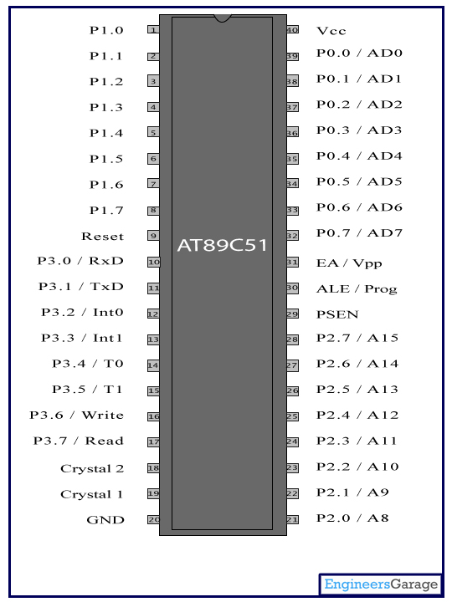

Figure 2: Pin Diagram of microcontroller

**6.2 Pin Description:**

|  |  |  |  |  |
| --- | --- | --- | --- | --- |
| **Pin No** | **Function** | | | **Name** |
| **1** | **8 bit input/output port (P1) pins** | | | **P1.0** |
| **2** | **P1.1** |
| **3** | **P1.2** |
| **4** | **P1.3** |
| **5** | **P1.4** |
| **6** | **P1.5** |
| **7** | **P1.6** |
| **8** | **P1.7** |
| **9** | **Reset pin; Active high** | | | **Reset** |
| **10** | **Input (receiver) for serial communication** | **RxD** | **8 bit input/output port (P3) pins** | **P3.0** |
| **11** | **Output (transmitter) for serial communication** | **TxD** | **P3.1** |
| **12** | **External interrupt 1** | **Int0** | **P3.2** |
| **13** | **External interrupt 2** | **Int1** | **P3.3** |
| **14** | **Timer1 external input** | **T0** | **P3.4** |
| **15** | **Timer2 external input** | **T1** | **P3.5** |
| **16** | **Write to external data memory** | **Write** | **P3.6** |
| **17** | **Read from external data memory** | **Read** | **P3.7** |
| **18** | **Quartz crystal oscillator (up to 24 MHz)** | | | **Crystal 2** |
| **19** | **Crystal 1** |
| **20** | **Ground (0V)** | | | **Ground** |
| **21** | **8 bit input/output port (P2) pins**  **/**  **High-order address bits when interfacing with external memory** | | | **P2.0/ A8** |
| **22** | **P2.1/ A9** |
| **23** | **P2.2/ A10** |
| **24** | **P2.3/ A11** |
| **25** | **P2.4/ A12** |
| **26** | **P2.5/ A13** |
| **27** | **P2.6/ A14** |
| **28** | **P2.7/ A15** |
| **29** | **Program store enable; Read from external program memory** | | | **PSEN** |
| **30** | **Address Latch Enable** | | | **ALE** |
| **Program pulse input during Flash programming** | | | **Prog** |
| **31** | **External Access Enable;  Vcc for internal program executions** | | | **EA** |
| **Programming enable voltage; 12V (during Flash programming)** | | | **Vpp** |
| **32** | **8 bit input/output port (P0) pins**  **Low-order address bits when interfacing with external memory** | | | **P0.7/ AD7** |
| **33** | **P0.6/ AD6** |
| **34** | **P0.5/ AD5** |
| **35** | **P0.4/ AD4** |
| **36** | **P0.3/ AD3** |
| **37** | **P0.2/ AD2** |
| **38** | **P0.1/ AD1** |
| **39** | **P0.0/ AD0** |
| **40** | **Supply voltage; 5V (up to 6.6V)** | | | **Vcc** |

Figure 3: Pin description of microcontroller

**Microcontroller Architecture**

**6.3.1. Microprocessor has following instructions to perform:**

1. Reading instructions or data from program memory ROM.

2. Interpreting the instruction and executing it.

3. Microprocessor Program is a collection of instructions stored in a Non-volatile memory.

4. Read Data from I/O device

5. Process the input read, as per the instructions read in program memory.

6. Read or write data to Data memory.

7. Write data to I/O device and output the result of processing to O/P device.

**6.3.2. 89c51 micro controller architecture:**

The 89c51 architecture consists of these specific features:

* Eight –bit CPU with registers A (the accumulator) and B
* Sixteen-bit program counter (PC) and data pointer (DPTR)
* Eight- bit stack pointer (PSW)
* Eight-bit stack pointer (Sp)
* Internal ROM or EPROM (8751) of 0(89c31) to 4K (89c51)
* Internal RAM of 128 bytes:

1. Four register banks, each containing eight registers
2. Sixteen bytes, which may be addressed at the bit level
3. Eighty bytes of general- purpose data memory

* Thirty –two input/output pins arranged as four 8-bit ports:p0-p3
* Two 16-bit timer/counters: T0 and T1
* Full duplex serial data receiver/transmitter: SBUF
* Control registers: TCON, TMOD, SCON, PCON, IP, and IE
* Two external and three internal interrupts sources.

**6.4 Functional Block Diagram of Microcontroller**



Figure 4: Functional Block Diagram of Microcontroller

**7. Hardware Description**

The block diagram of the system is as shown in the fig. The system basically consists of a

1. LDR
2. Relay
3. Power supply

7.1. LDR (Light Dependent Resistors)

LDRs or Light Dependent Resistors are very useful especially in light/dark sensor circuits. Normally the resistance of an LDR is very high, sometimes as high as 1000 000 ohms, but when they are illuminated with light resistance drops dramatically.



Figure 5: LDR (Light Dependent Resistors)

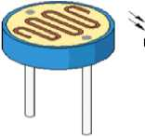

The animation opposite shows that when the torch is turned on, the resistance of the LDR falls, allowing current to pass through.

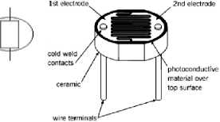

**7.2. Light sensor circuit:**

When the light level is low the resistance of the LDR is high. This prevents current from flowing to the base of the transistors. Consequently the LED does not light.  
  
However, when light shines onto the LDR its resistance falls and current flows into the base of the first transistor and then the second transistor. The LED lights.

The preset resistor can be turned up or down to increase or decrease resistance, in this way it can make the circuit more or less sensitive.



Figure 6: Light sensor circuit

**8. Relay**

A relay is an electrical switch that opens and closes under the control of another electrical circuit. In the original form, the switch is operated by an electromagnet to open or close one or many sets of contacts. It was invented by Joseph Henry in 1835. Because a relay is able to control an output circuit of higher power than the input circuit, it can be considered to be, in a broad sense, a form of an electrical amplifier.

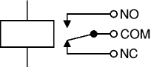

## 

Figure 7: Relay

## 8.1. Operation

When a current flows through the coil, the resulting magnetic field attracts an armature that is mechanically linked to a moving contact. The movement either makes or breaks a connection with a fixed contact. When the current to the coil is switched off, the armature is returned by a force approximately half as strong as the magnetic force to its relaxed position. Usually this is a spring, but gravity is also used commonly in industrial motor starters. Since relays are switches, the terminology applied to switches is also applied to relays. A relay will switch one or more *poles*, each of whose contacts can be *thrown* by energizing the coil in one of three ways:

* Normally-open (**NO**) contacts connect the circuit when the relay is activated; the circuit is disconnected when the relay is inactive. It is also called a **Form A** contact or "make" contact.
* Normally-closed (**NC**) contacts disconnect the circuit when the relay is activated; the circuit is connected when the relay is inactive. It is also called a **Form B** contact or "break" contact.
* Change-over, or double-throw, contacts control two circuits: one normally-open contact and one normally-closed contact with a common terminal. It is also called a **Form C** contact or "transfer" contact. If this type of contact utilizes “make before break" functionality, then it is called a **Form D** contact.

The picture shows a working relay with its coil and switch contacts. You can see a lever on the left being attracted by magnetism when the coil is switched on. This lever moves the switch contacts

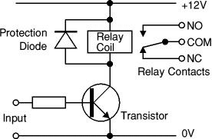

Figure 8: Relay in the circuit

The relay's switch connections are usually labelled COM, NC and NO:

* COM = Common, always connect to this; it is the moving part of the switch.
* NC = Normally Closed, COM is connected to this when the relay coil is off.
* NO = Normally Open, COM is connected to this when the relay coil is on.
* Connect to COM and NO if you want the switched circuit to be on when the relay coil is on.
* Connect to COM and NC if you want the switched circuit to be on when the relay coil is off.

# Automatic Switching of Street Lights by using LDR and Relay:

# We decided to use an light dependent resistor. here in this circuit LDR has low resistance in brightness(only few ohms) and very high resistance in complete  darkness(nearly 1M ohm).so the transistor Q1 becomes on in day times and Q2 becomes off and hence the relay remains in NC(normally closed) state and the lamp will not glow. at night the transistor Q1 becomes OFF and Q2 becomes ON and hence the relay goes to NO(normally open) state and the lamp glows. and the sensitivity of the device can be varied by adjusting the potentiometer now I just want to know are there any defects in this circuit so can u please help me in knowing the drawbacks and correcting them and I want to know whether i can connect a relay in place of a fuse as shown at

Bottom: 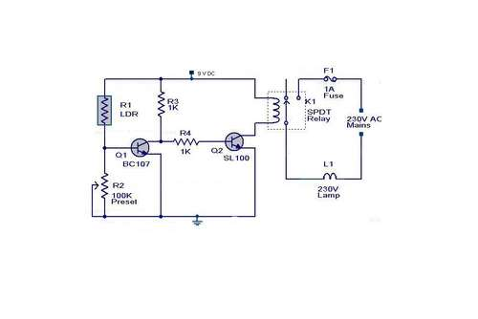

Figure 9: Automatic Switching Of Street Lights by Using Ldr and Relay

**9. Power Supply**

A variable regulated power supply, also called a variable bench power supply, is one where you can continuously adjust the output voltage to your requirements. Varying the output of the power supply is the recommended way to test a project after having double checked parts placement against circuit drawings and the parts placement guide. This type of regulation is ideal for having a simple variable bench power supply. Actually this is quite important because one of the first projects a hobbyist should undertake is the construction of a variable regulated power supply. While a dedicated supply is quite handy e.g. 5V or 12V, it's much handier to have a variable supply on hand, especially for testing. Most digital logic circuits and processors need a 5 volt power supply. To use these parts we need to build a regulated 5 volt source. Usually you start with an unregulated power supply ranging from 9 volts to 24 volts DC (A 12 volt power supply is included with the Beginner Kit and the Microcontroller Beginner Kit.). To make a 5 volt power supply, we use a LM7805 voltage regulator IC.

**9.1. Circuit Features**

Brief description of operation: Gives out well regulated +5V output, output current capability of 100 mA

* Circuit complexity: Very simple and easy to build
* Circuit performance: Very stable +5V output voltage, reliable operation
* Availability of components: Easy to get, uses only very common basic components
* Applications: Part of electronics devices, small laboratory power supply
* Power supply voltage: Unregulated DC 8-18V power supply
* Power supply current: Needed output current + 5 mA

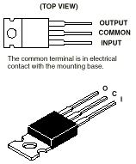

Figure 10: Circuit Features

**9.2. Block Diagram**

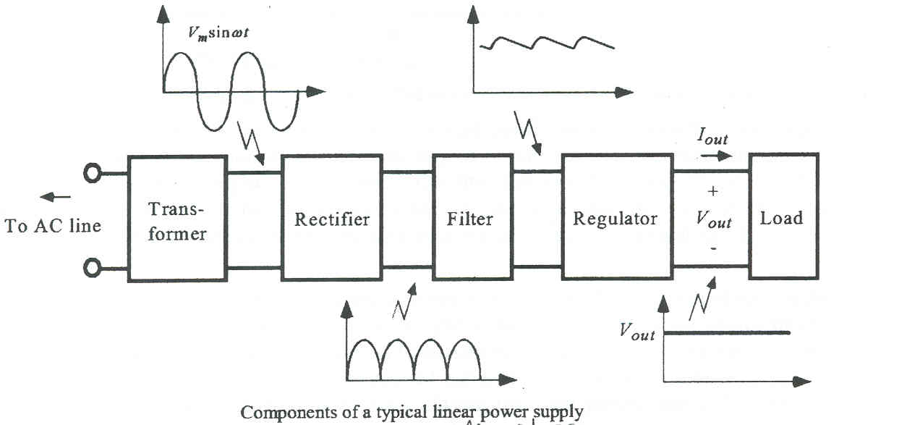

Figure 11: Block Diagram of Power supply

**9.3. Circuit Diagram**

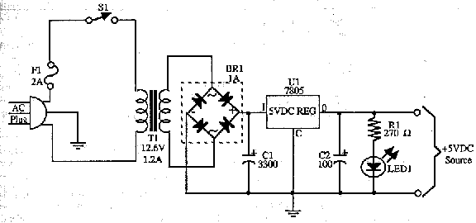

Figure 12 : Circuit diagram of A.C to D.C converter

**9.4. Basic Power Supply Circuit**

Above is the circuit of a basic unregulated dc power supply. A bridge rectifier D1 to D4 rectifies the ac from the transformer secondary, which may also be a block rectifier such as WO4 or even four individual diodes such as 1N4004 types. (See later re rectifier ratings).

The principal advantage of a bridge rectifier is you do not need a centre tap on the secondary of the transformer. A further but significant advantage is that the ripple frequency at the output is twice the line frequency (i.e. 50 Hz or 60 Hz) and makes filtering somewhat easier.

As a design example consider we wanted a small unregulated bench supply for our projects. Here we will go for a voltage of about 12 - 13V at a maximum output current (IL) of 500ma (0.5A). Maximum ripple will be 2.5% and load regulation is 5%.

Now the RMS secondary voltage (primary is whatever is consistent with your area) for our power transformer T1 must be our desired output Vo PLUS the voltage drops across D2 and D4 ( 2 * 0.7V) divided by 1.414.

This means that Vsec = [13V + 1.4V] / 1.414 which equals about 10.2V. Depending on the VA rating of your transformer, the secondary voltage will vary considerably in accordance with the applied load. The secondary voltage on a transformer advertised as say 20VA will be much greater if the secondary is only lightly loaded.

If we accept the 2.5% ripple as adequate for our purposes then at 13V this becomes 13 * 0.025 = 0.325 Vrms. The peak to peak value is 2.828 times this value. Vrip = 0.325V X 2.828 = 0.92 V and this value is required to calculate the value of C1. Also required for this calculation is the time interval for charging pulses. If you are on a 60Hz system it it 1/ (2 * 60 ) = 0.008333 which is 8.33 milliseconds. For a 50Hz system it is 0.01 sec or 10 milliseconds.

Remember the tolerance of the type of capacitor used here is very loose. The important thing to be aware of is the voltage rating should be at least 13V X 1.414 or 18.33. Here you would use at least the standard 25V or higher (absolutely not 16V).With our rectifier diodes or bridge they should have a PIV rating of 2.828 times the Vsec or at least 29V. Don't search for this rating because it doesn't exist. Use the next highest standard or even higher. The current rating should be at least twice the load current maximum i.e. 2 X 0.5A or 1A. A good type to use would be 1N4004, 1N4006 or 1N4008 types.

These are rated 1 Amp at 400PIV, 600PIV and 1000PIV respectively. Always be on the lookout for the higher voltage ones when they are on special.

**9.5. Transformer Rating**

In our example above we were taking 0.5A out of the Vsec of 10V. The VA required is 10 X 0.5A = 5VA. This is a small PCB mount transformer available in Australia and probably elsewhere.

This would be an absolute minimum and if you anticipated drawing the maximum current all the time then go to a higher VA rating.

The two capacitors in the primary side are small value types and if you don't know precisely and I mean precisely what you are doing then OMIT them. Their loss won't cause you heartache or terrible problems.

**9.6. Construction**

The whole project MUST be enclosed in a suitable box. The main switch (preferably double pole) must be rated at 240V or 120V at the current rating. All exposed parts within the box MUST be fully insulated, preferably with heat shrink tubing.

**10. Future Enhancement**

Wireless is the buzz of communication industry today. The field of wireless communication is growing leaps and bounds day by day. There have been many advancements taking place in the semiconductor industry leading to more and more advancements in wireless technology. The main aim of the project is to save the power; by using effectively we can save more power, as we know that there is shortage of power nowadays in every where mostly in villages etc. So to overcome that we can provide street lights automatically with the centralized intelligent systems. So in future we can design many more advanced technologies to save power.

**Significance**

The significance of the project is to deliver street light to everyone with savings of energy and power. We can also reduce money cost by using LDR and relay. The street lighting system is very easy to made. We can make it providing low cost and a few labour . Its saves a huge amount of power and energy for us.

**Scope**

The duration of this project was just over one year from January 2015

to March 2016. The summer of 2015 was dedicated to the design and installation

of the equipment and instrumentation. Data were collected late summer, to late

Fall 2015, after which, the winter experimentation was installed, and data

Collected from November 2015 to March 2016. It would have been ideal to

Collect further data in the summer of 2016, however, due to time and financial

Constraints this was not possible.

**References:**

* [www.microsoftsearch.com](http://www.microsoftsearch.com)
* [www.geocities.com](http://www.geocities.com)
* [Central Electricity Generating Board](http://en.wikipedia.org/wiki/CEGB) (1982). Modern Power Station Practice. Pergamon. [ISBN](http://en.wikipedia.org/wiki/International_Standard_Book_Number) [0-08-016436-6](http://en.wikipedia.org/wiki/Special:BookSources/0-08-016436-6).
* Daniels, A.R. (1985). Introduction to Electrical Machines. Macmillan. [ISBN](http://en.wikipedia.org/wiki/International_Standard_Book_Number) [0-333-19627-9](http://en.wikipedia.org/wiki/Special:BookSources/0-333-19627-9).
* Flanagan, William (1993). Handbook of Transformer Design and Applications. McGraw-Hill. [ISBN](http://en.wikipedia.org/wiki/International_Standard_Book_Number) [0-0702-1291-0](http://en.wikipedia.org/wiki/Special:BookSources/0-0702-1291-0)
* <http://en.wikipedia.org/wiki/Microcontroller#History>
* [www.national.com](http://www.national.com)
* [www.atmel.com](http://www.atmel.com)

Burt, C. M., A. J. Clemmens, R. Bliesner, J.L. Merriam, and L. Hardy. 2000.

*Selection of irrigation methods for agriculture*. On-farm irrigation committee of

the environment and water resources institute. ASCE.

Census of Agriculture. 2001. Statistics Canada. Available at:

<http://www40.statcan.ca/l01/cst01/agrc05a.htm>

Collares-Pereira M., and A. Rabl. 1979. The average distribution of solar

radiation-correlations between diffuse and hemispherical and between daily and

hourly insolation values. *Solar Energy*. 22: 155-164.

Cooper, P. I. 1969. The absorption of radiation in solar stills. *Solar Energy*. 12:

333–346.

Daud, A-K., and M. M. Mahmoud. 2005. Solar powered induction motor-driven

water pump operating on a desert well, simulation and field tests. *Renewable*

*Energy.* 30: 701-714.

Del Cueto, J. A. 2002. Comparison of energy production and performance from

flat-plate photovoltaic module technologies deployed at fixed tilt. *Photovoltaic*

*Specialist Conference, 2002*. Conference Record of the Twenty-ninth IEEE. New

Orleans, Louisiana. 1523-1526. Available at:

http://ieeexplore.ieee.org/iel5/8468/26685/01190901.pdf?tp=&arnumber=119090

1&isnumber=26685

Duffie, J. A., and W. A. Beckman. 1991. *Solar engineering of thermal processes*,

2nd Edition. New York, USA: John Wiley & Sons, Inc.

Ellis, A. W, and D. J. Leathers. 1999. Analysis of cold airmass temperature

modification across the US Great Plains as a consequence of snow depth and

albedo. *Journal of Applied Meteorology.* 38(6): 696-711.

Environment Canada. 2006. Climate Data Online. Available at:

http://www.climate.weatheroffice.ec.gc.ca/climateData/canada_e.html.

Erbs, D. G., S. A. Klein, and J. A. Duffie.1982. Estimation of the diffuse radiation

fraction for hourly, daily, and monthly-average global radiation. *Solar Energy*.

28(4): 293-302.

Evans, D.L. 1981. Simplified method for predicting photovoltaic array output.

*Solar Energy.* 27(6): 555-560.

Evans, J. 2006. Energy conscious AC domestic booster systems. Available at:

[www.pacificliquid.com](http://www.pacificliquid.com)

FAO Statistics Division. 2004. FAO Country Profiles. Available at:

<http://www.fao.org/ES/ess/yearbook/vol_1_2/pdf/Canada.pdf>

Galdabini, S., G. Giuliani, and N. Robotti. 1992. Photoelectricity within classical

physics: from the photocurrents of Edmund Becquerel to the first measure of the

electron charge. *Proceedings of the Conference on ‘History of Physics in Europe*

*in the 19th and 20th Centuries’*. Como, Italy. 149 - 156. Available at:

http://fisicavolta.unipv.it/percorsi/pdf/napesi.pdf#search=%22Edmond%20Becqu

erel%20in%201839%20%22

Gottschalg, R., J. A. del Cueto, T. R. Betts, and D. G. Infield. 2005. Seasonal

performance of a-Si single and multijunction modules in two locations.

*Photovoltaic Specialist Conference, 2005*. Conference Record of the Thirty-first

IEEE. 1484-1487. Available at:

http://ieeexplore.ieee.org/iel5/9889/31426/01488423.pdf?isnumber=31426&arnu

mber=1488423

Gxasheka, A. R., E. E. van Dyk, and E. L. Meyer. 2005. Evaluation of

performance parameters of PV modules deployed outdoors. *Renewable Energy*.

30: 611-620.

Hamidat, A., B. Benyoucef, and T. Hartani. 2003. Small-scale irrigation with

photovoltaic water pumping system in Sahara regions. *Renewable Energy.* 28:

1081-1096.

Hamza, A. A., and A. Z. Taha. 1995. Performance of submersible PV solar

pumping systems under conditions in the Sudan. *Renewable Energy.* 6(5-6): 491-

495.

Hargreaves, G. H., and Z. A. Samani. 1982. Estimating potential

evapotranspiration. *Journal of Irrigation and Drainage Engineering*, Div. ASCE.

108: 225-230.

Hay, J. E. 1976. A revised method for determining the direct and diffuse

components of the total short wave radiation. *Atmosphere.* 14: 278-287.

Hishikawa, Y., and S. Okamoto. 1994. Dependence of the I-V characteristics of

amorphous silicon solar cells on illumination intensity and temperature. *Solar*

*Energy Materials and Solar Cells.* 33: 157-168.

Hrayshat, E. S., and M. S. Al-Soud. 2004. Potential of solar energy development

for water pumping in Jordan. *Renewable Energy*. 29: 1393-1399.

Hsiao Y. R., and B. A. Blevins.1984. Direct coupling of photovoltaic power

source to water pumping system. *Solar Energy*. 32: 489-498.

**Discussion of Findings**

Here we are saving lot of power without any wastage, by these advanced technologies we can design many more systems which can be done by solar lights and through these solar lights we have a vast usage at the same time we can do automatic systems instead of doing it manually.

Secondly, using highly advanced IC’s and with the help of growing technology the project has been successfully implemented.

**Summary**

The field of wireless communication is growing leaps and bounds day by day. There have been many advancements taking place in the semiconductor industry leading to more and more advancements in wireless technology. The main aim of the project is to save the power; by using effectively we can save more power, as we know that there is shortage of power nowadays in every where mostly in villages etc. So to overcome that we can provide street lights automatically with the centralized intelligent systems. So in future we can design many more advanced technologies to save power.

**Conclusion**

The project “Automatic Street Light Control System with LDR and Microcontroller” has been successfully designed and tested.

Here we are saving lot of power without any wastage, by these advanced technologies we can design many more systems which can be done by solar lights and through these solar lights we have a vast usage at the same time we can do automatic systems instead of doing it manually.

Secondly, using highly advanced IC’s and with the help of growing technology the project has been successfully implemented.

**Recommendation**

Based on this research, the following recommendations are made for

Future studies:

**Field work:**

i. A longer period of data collection, in a single location, would be

Recommended. At least two complete years would allow year to year and

month to month comparison. This would also provide the time to identify

and correct all potential defects in the system, from leaks to wiring to

pump efficiency to sensor calibration.

ii. It would be important to measure the voltage after the linear current

booster as well as before. In this way, the actual efficiency of the linear

current booster could be determined as well as the power input directly to

the pump motor. This would provide sufficient information to determine

the true overall efficiency of the pump.

iii. To maximise the efficiency of the photovoltaic modules and thus greatly

increase the volume of water pumped, use of a sun-tracking system should

be considered. A tracking system allows the panels to follow the

movement of the sun through out the day. An automated two dimensional

tracking system is recommended. However, there are less expensive

options. A tracking mechanism developed by Wolfgang Scheffler (1986)

originally for solar cookers, works on a spring controlled with mechanical

clockwork. For a simpler system, the panels could be mounted on a

rotating pole. In this way, they could be manually rotated, three times a

day, to face the sun. The mounting bracket could also be designed with a

sliding and locking mechanism, so that the tilt angle could be easily

changed on a weekly or monthly basis.

iv. A more efficient PV pumping system could be studied including the use of

a variable speed motor and submersible pump. If a surface water pump

must be used due to cost or maintenance concerns, then it would be

important to shorten the length of the suction intake to a maximum of 5 m.

97

v. Battery storage would decrease the overall system efficiency, however if

precise and continual power delivery was a concern due to the type of

pump, this would be an important consideration.

vi. Pumping water directly to a storage tank would decrease the number of

variables to consider in the design phase, as the outlet pressure would be

kept constant.

vii. If possible, use of a clean water source would eliminate the possibility of

obstruction in the suction intake, while at the same time prolonging the life

of the pump.

**Modelling:**

viii. To improve performance of the modified Hargreaves-Samani inland

model for global solar radiation, a site specific coefficient could be used if

long term quality solar radiation data is available.

ix. To improve the PV electrical output model, further studies could be done

in the development of a more accurate cloud cover coefficient as well as a

ground reflectance coefficient that takes actual snow cover into

consideration, perhaps based on a combination of average temperature,

precipitation, and relative humidity.

x. The use of minutely or hourly (as opposed to daily) global solar radiation

input data to determine the beam, diffuse, and reflected components of

solar radiation could improve the prediction of hourly solar radiation in the

plane of the PV array.

Finally, it would be recommended to take this technology to a rural or

developing area, in order to research practical applications. Considerations

for successful application would include many more parameters than a similar

study in North America could incorporate, from identifying local interest and

technicians for operation and maintenance, to finding appropriate and readily

available materials and technologies.

**Work Cited References**

References:

1. D. A. Devi and A. Kumar, Design and Implementation of CPLD based Solar Power Saving System for Street Lights and Automatic Traffic Controller, International Journal of Scientific and Research Publications, Vol. 2, Issue 11, November 2012.
2. J. Mohelnikova, Electric Energy Savings and Light Guides, Energy& Environment, 3rd IASME/WSEAS International Conference on, Cambridge, UK, February 2008, pp.470-474.
3. M. A. Wazed, N. Nafis, M. T. Islam and A. S. M. Sayem, Design and Fabrication of Automatic Street Light Control System, Engineering e-Transaction, Vol. 5, No. 1, June 2010, pp 27-34.
4. R. Priyasree, R. Kauser, E. Vinitha and N. Gangatharan, Automatic Street Light Intensity Control and Road Safety Module Using Embedded System, International Conference on Computing and Control Engineering, April 2012.
5. K. S. Sudhakar, A. A. Anil, K. C. Ashok and S. S. Bhaskar, Automatic Street Light Control System, International Journal of Emerging Technology and Advanced Engineering, Vol. 3, May 2013, PP. 188-189.
6. K.Y. Rajput, G. Khatav, M. Pujari, P. Yadav.
7. M. Popa, C. Cepi§ca, Energy Consumption Saving Solutions Based on Intelligent Street Lighting Control System. U.P.B. Sci. Bull., Vol. 73, April 2011, PP. 297-308.

**Appendix**

**Cost:**

Equipments Estimate Rate Cost (TK)

Microcontroller 10 pcs 8086 10000

Transformer 1 pcs 3-phase, 3KVA 70,000

Circuit breaker 20pcs 12 A 80,00

Switches 20 pcs 220V 2,000

Wire 1000m 220V 10,000

Relay 10 pcs 220 V 4800

LDR 10 pcs220V 3000

Total cost 1, 07,800 (TK)

Wiring Schematic for Data Logger CR23X

Analog inputs to measure data:

1. Thermocouple 1

2. Thermocouple 2

3. Ambient Temperature Probe

4. Pressure Transducer (through 100 ohm resistor)

5. Paddle Wheel Flow Meter (through 100 ohm resistor)

6. Panel 1 Voltage (through 10:1 voltage divider)

7. Panel 2 Voltage (through 10:1 voltage divider)

8. Combined Current before Linear Current Booster

9. Combined Current after Linear Current Booster

10. Thermocouple 3

11. Thermocouple 4

Excitation, power, and control:

A. Switched excitation output (for temperature probe)

B. 12 V power supply (to power flow meter)

C. Control I/O (to toggle relay between panels and pump)

D. Control I/O (to toggle relay between 24 V power source and current

Sensors)